Unit 4 Assessment

For this assessment, I am going to make use of the Address table to store customer addresses. I will then update the existing customer table that was provided so that it has a foreign key that links to this newly made address. (See unit 3 for ERD diagram relationship between customers and address)
Find out how many customers there are

Which gave me 200 so I know now to create 200 lines of fake address data.
Here is the AI prompt I used to generate 200 lines of fake address data. I did this using Gemini.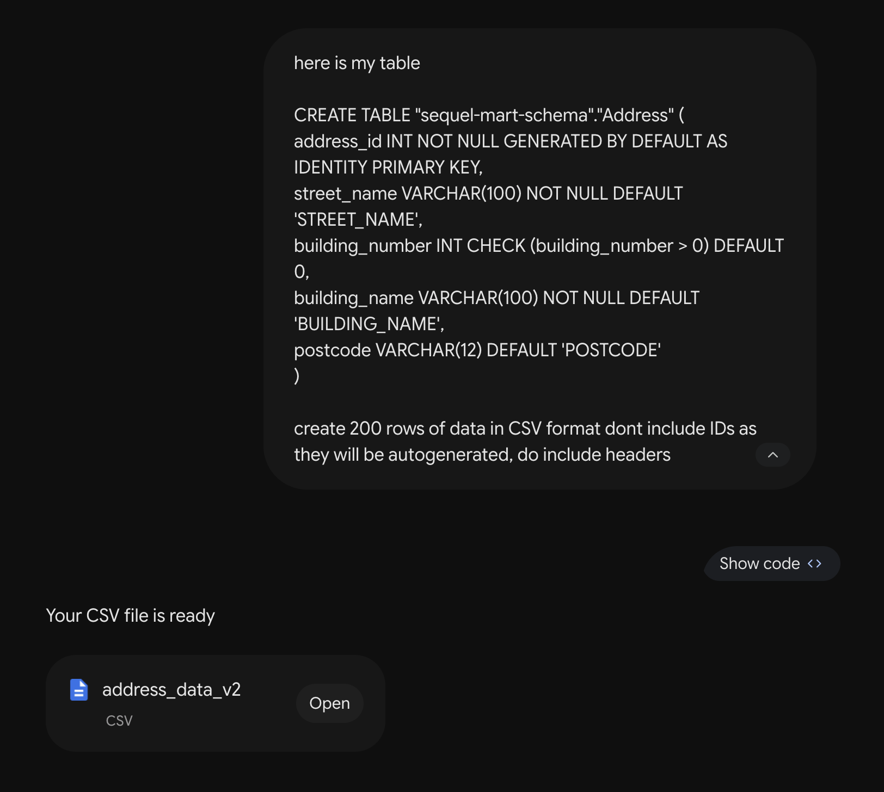

Created staging table for data
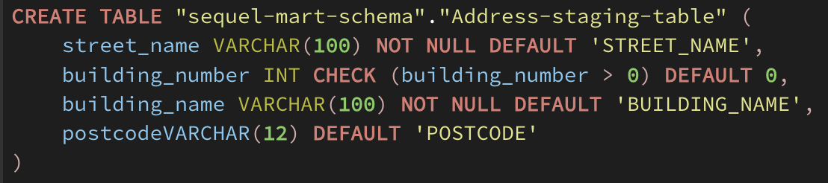

Which gave me these tables
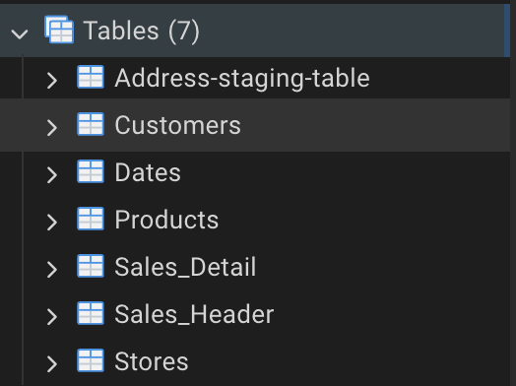

Using the import functions on PGAdmin I imported my data from the datafile which looked liked this
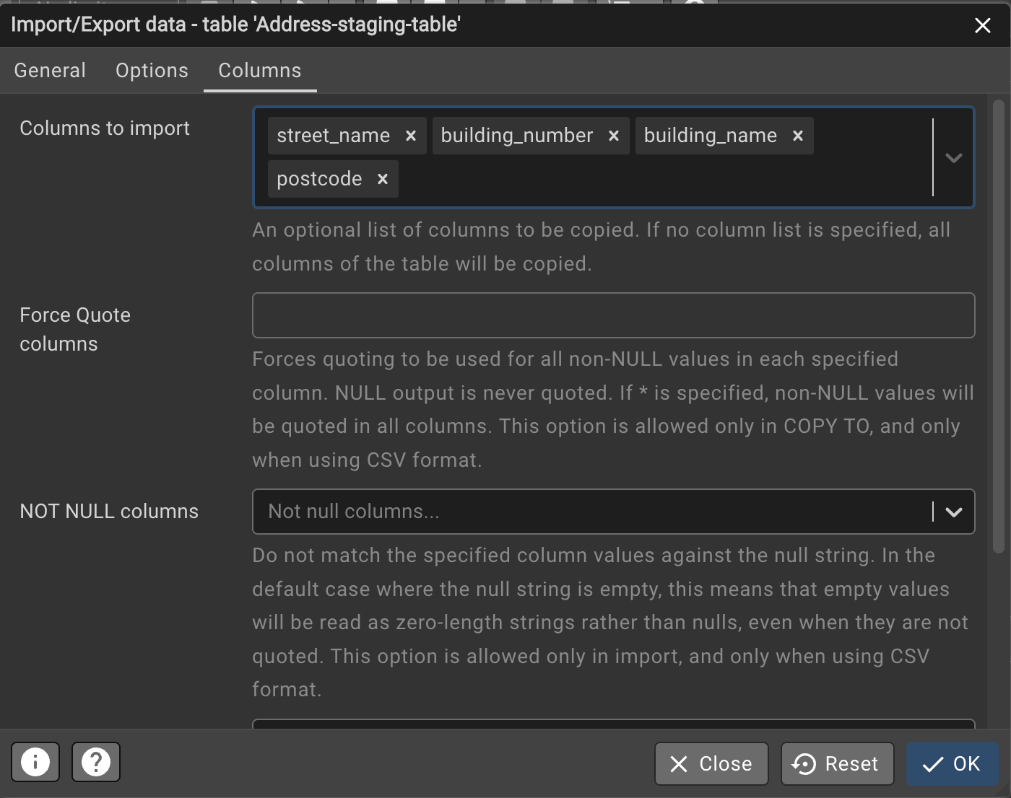

For reference, the table of data looks like this
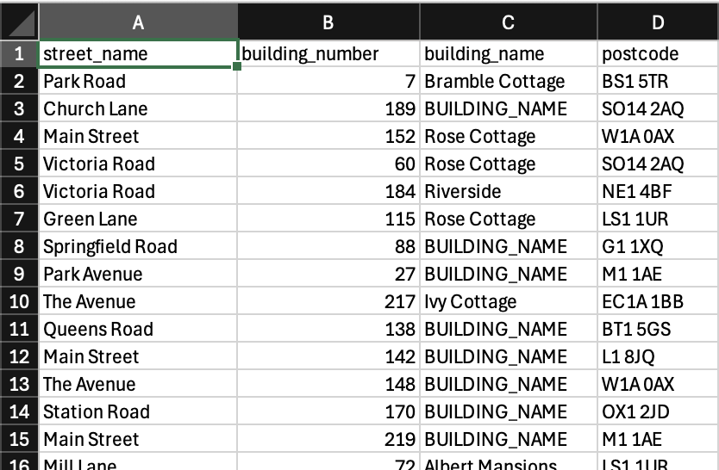

After staging, when calling this query

We get this result in pg admin

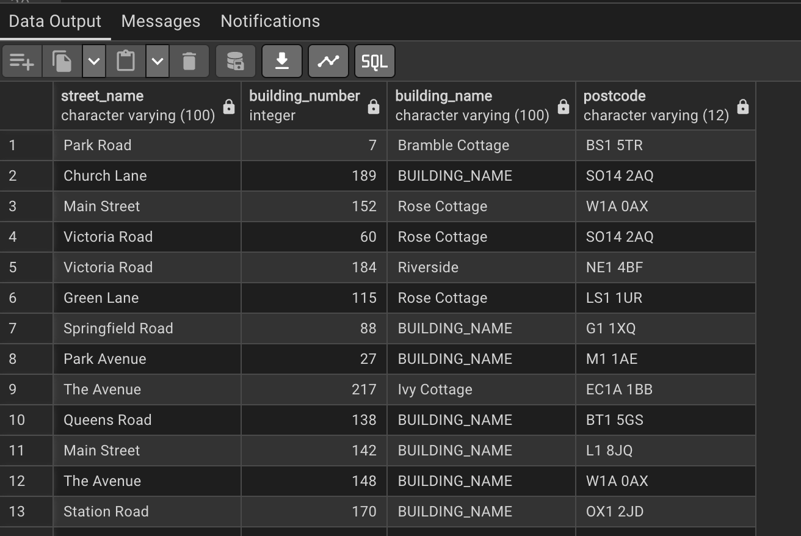

Then we create the address table with this query.
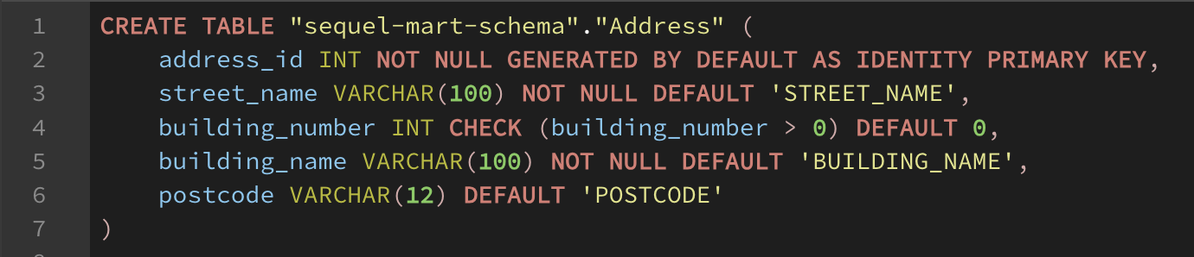

Giving us the address table
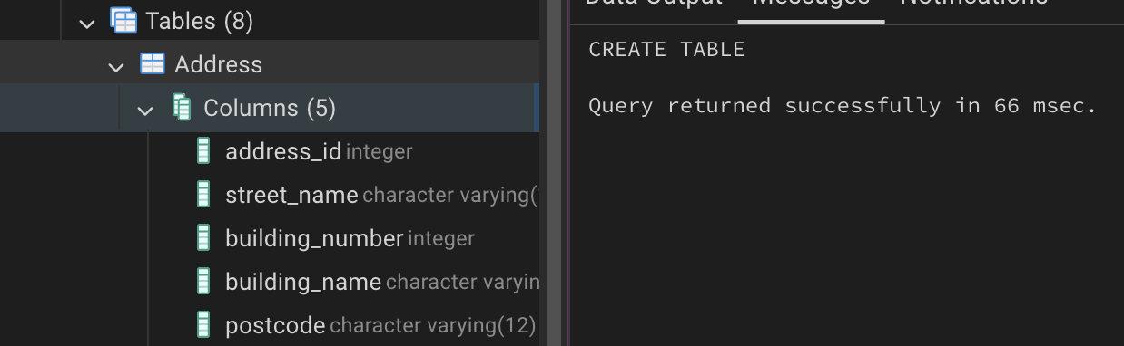

Where we can now call this query to migrate all the data from the staging table to the address table
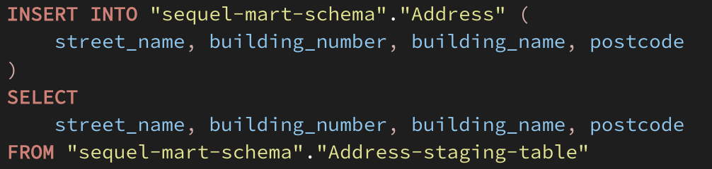

And by calling this query

We get the results from the address table
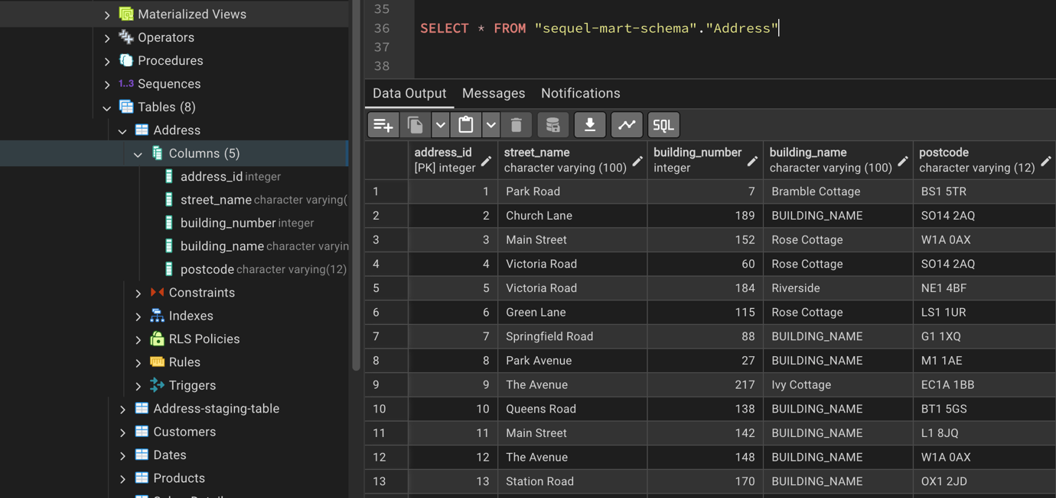

Then I edited the Customer table to link the customer to the address table with address_id as a foreign key and also add in two (optional) fields.
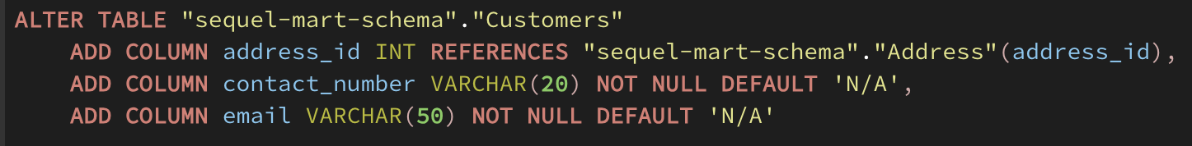

Initially, after this change, our customer table looks like this
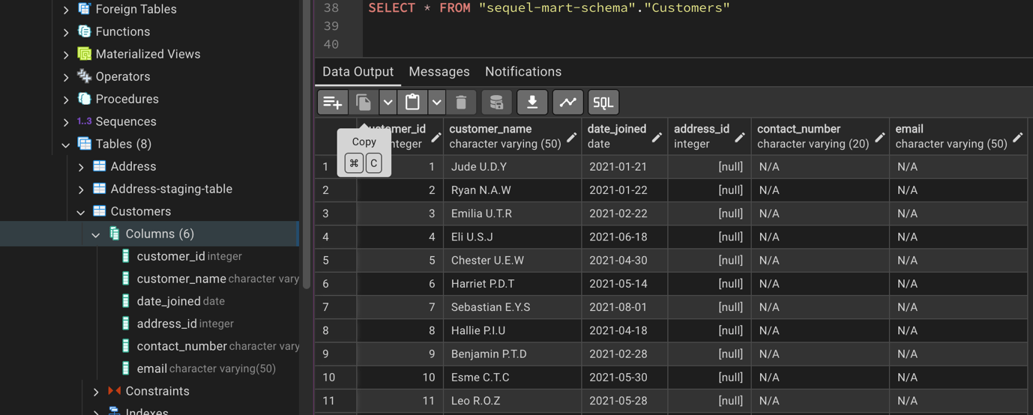
And then we can get all the IDs from address table and assign it row by row to each customer address_id so that every customer now has an address using this query
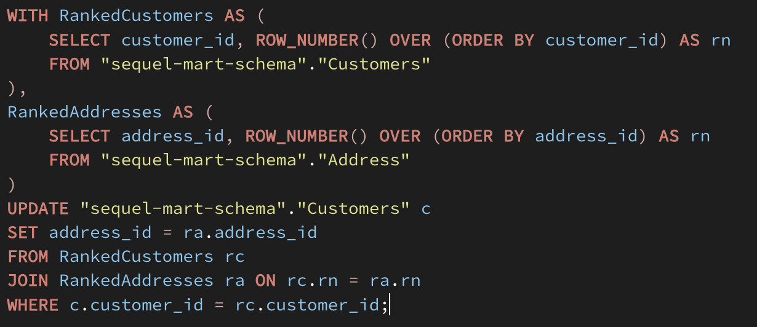

And after querying the customer table again we end up with this!

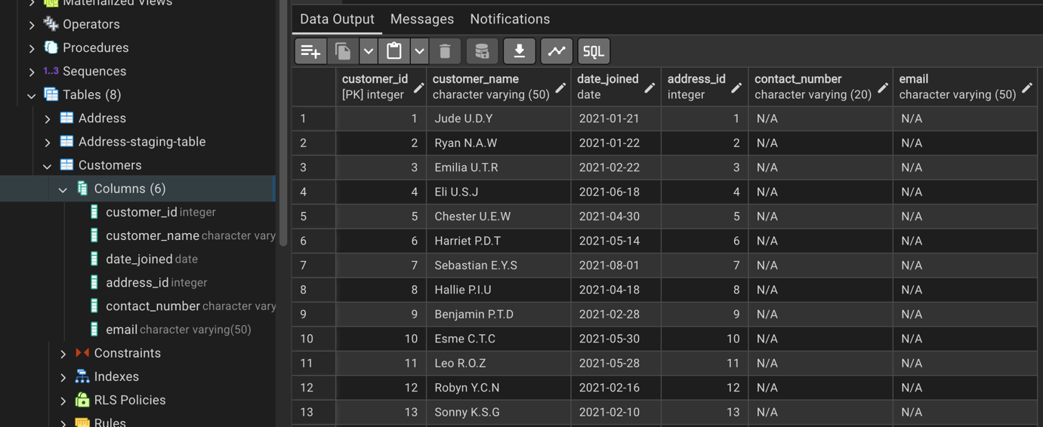

Where we can see that our customers now have ids linking to an id in the table! To show this, customer 1 should have the address that relates to the first address in the address table (since we did a row by row mapping). We can see this by using this query which joins the two tables (Customers and Address) where the customer ID = 1 and the customer.address_id = address.address.id
Our tables are successfully population and linked!

